**CHAPTER 1**

**1.1 PROJECT OVERVIEW:**

In this paper, in order to avoid the complication due to late identification of the Diabetic retinopathy, we develop a deep learning system that can detect early-to-late stages of diabetic retinopathy by using Fundus images as dataset for training and testing the model. The deep learning models like Resnet-50, Alexnet, VGG16, Google-Net, U-Net are under studied and the deep learning model of VGG16 is trained and used in this project for detection of diabetic retinopathy of the person by getting their own registerable login for prediction of the disease with the stage of its severity as the result with proper mail confirmation..

**1.2 PURPOSE:**

The diabetic retinopathy is based on by retina's blood vessels being damaged. As the retina is the most fragile part of the eye the damage of blood vessels may lead to blurry, less strong eyesight as well as the absence of all vision. There might be no symptoms of diabetic retinopathy at first. Early symptoms of the disease can be barely visible or minor. The situation of this issue could deteriorate over time and lead in first partial and eventually entire blindness. Early recognition of this issue is therefore highly recommend. By getting the eyes examined under dilated conditions by an ophthalmologist or optometrist, diabetic retinopathy can be detected.

**CHAPTER 2**

**LITERATURE SURVEY**

**2.1 SURVEY REPORT - 1**

**TITLE:** A Deep Learning Based Diabetic Retinopathy Detection from Retinal Images

**Author**: [Mini Yadav](https://ieeexplore.ieee.org/author/37088925418), [Raghav Goel](https://ieeexplore.ieee.org/author/37088387336), [D Rajeswari](https://ieeexplore.ieee.org/author/37088493855)

**Published in:** IEE, [International Conference on Intelligent Technologies (CONIT)](https://ieeexplore.ieee.org/xpl/conhome/9497779/proceeding)

**Year of Publication:** 2021

**Objective:**

Diabetes is increased tremendously due to metabolism. Lack of early detection, prolonged diabetics might lead to medical complications such as heart problems, eye vision problems, skin issues etc. Diabetic retinopathy (DR) is a frequent abnormality of diabetics. In this paper, we propose computer vision based technique to analyze and predict diabetes from the retinal input images. The framework developed was evaluated on open access public repository datasets, achieving an accuracy of 98.50% using CNN as compared to the accuracy of 87.40% achieved by SVM. These results perform better than several advanced unsupervised ML techniques. It results in decrease of procedural complexity and improved assessment metrics, hence making it suitable to be used in the diagnosis of DR using retinal image analysis.

**2.2 SURVEY REPORT - 2**

**Title:** Accurate Prediction of COVID-19 (+) Using AI Deep VGG16 Model

**Author:** [Alavikunhu Panthakkan](https://ieeexplore.ieee.org/author/37086637510),[S.M.Anzar](https://ieeexplore.ieee.org/author/37088687062),[Saeed Al Mansoori](https://ieeexplore.ieee.org/author/37086190692),[Hussain Al Ahmad](https://ieeexplore.ieee.org/author/37086639158)

**Published in:** IEE,[International Conference on Signal Processing and Information Security (ICSPIS)](https://ieeexplore.ieee.org/xpl/conhome/9340125/proceeding)

**Year of Publication:** 2020

**Objective:**

Current research aims at the efficient prediction of COVID-19 (+) by employing advanced machine intelligence techniques by means of lung X-rays. In this paper, we have presented the promising VGG16 transfer learning model for the accurate and faster diagnosis of COVID-19 (+).  The system provides a binary classification of the lung X-ray image into COVID-19 (+) and Normal. The suggested approach is extremely efficient and precise, for that reason, it can be used to aid and support radiologists and healthcare professionals to identify COVID-19 (+) utilizing the lung X-rays.

**2.3 SURVEY REPORT – 3**

**Title:** A Deep Learning Based Distributed Smart Surveillance Architecture using Edge and Cloud Computing

**Author:** [Halil Can Kaskavalci](https://ieeexplore.ieee.org/author/37087049752), [Sezer Goren](https://ieeexplore.ieee.org/author/37338239000)

**Published in:** IEEE, [International Conference on Deep Learning and Machine Learning in Emerging Applications (Deep-ML)](https://ieeexplore.ieee.org/xpl/conhome/8870906/proceeding)

**Year of Publication:** 2019

**Objective:**

Smart surveillance is getting increasingly popular as technologies become easier to use and cheaper. Traditional surveillance records video footage to a storage device continuously. Newer devices with Internet connection save footage to the Cloud. This feature comes with bandwidth requirements and extra Cloud costs. In this paper, we propose a deep learning based, distributed, and scalable surveillance architecture using Edge and Cloud computing. Our design reduces both the bandwidth and as well as the Cloud costs significantly by processing footage prior sending to the Cloud.

**2.4 SURVEY REPORT – 4**

**Title:** Automatic Classification of Artery/Vein from Single Wavelength Fundus Images

Author: [P. Kevin Raj](https://ieeexplore.ieee.org/author/37086861917), [Aniketh Manjunath](https://ieeexplore.ieee.org/author/37088407183), [J. R. Harish Kumar](https://ieeexplore.ieee.org/author/37841533300), [Chandra Sekhar Seelamantula](https://ieeexplore.ieee.org/author/37545336100)

**Published in:** [IEEE, 17th International Symposium on Biomedical Imaging (ISBI)](https://ieeexplore.ieee.org/xpl/conhome/9091448/proceeding)

**Year of Publication: 2020**

**Objective:**

Vessels are regions of prominent interest in retinal fundus images.  In this paper, we propose an automated technique for the classification of arteries and veins from single-wavelength fundus images using convolutional neural networks employing the ResNet-50 backbone and squeeze-excite blocks. The proposed method is trained on publicly available fundus image datasets, namely RITE, LES-AV, IOSTAR, and cross-validated on the HRF dataset. The standard performance metrics, such as average sensitivity, specificity, accuracy, and area under the curve for the datasets mentioned above, are 92.8%, 93.4%, 93.4%, and 97.5%, respectively, which are superior to the state-of-the-art methods.

**2.5 SURVEY REPORT – 5**

**Title:** Categorical Image Classification Based On Representational Deep Network (RESNET)

**Author:** [Arpana Mahajan](https://ieeexplore.ieee.org/author/37086963534), [Sanjay Chaudhary](https://ieeexplore.ieee.org/author/37086959539)

**Published in:** IEEE, [International conference on Electronics, Communication and Aerospace Technology (ICECA)](https://ieeexplore.ieee.org/xpl/conhome/8811522/proceeding)

**Year of Publication:** 2019

**Objective:**

Categorical Image Classification needs thousands of images to train. Also, System needs more time to extract the features as well as classification. In the proposed System uses more, deep convolutional neural network to categorize thousands of high-resolution images into eight different classes. We have extracted image features from a pre-trained Representational deep Neural network (RESNET), and use that features to train machine learning Support vector machine (SVM) classifier. Representational deep networks makes feature extraction easiest and fastest way use than any other conventional network methods. In this research paper we are describe Image Categorical classification using proposed representational deep networks (RESNET).

**2.1 EXISTING PROBLEM**

* **Diabetic macular edema (DME).** Over time, about 1 in 15 people with diabetes will develop DME. DME happens when blood vessels in the retina leak fluid into the macula (a part of the retina needed for sharp, central vision). This causes blurry vision.
* **Neovascular glaucoma.** Diabetic retinopathy can cause abnormal blood vessels to grow out of the retina and block fluid from draining out of the eye. This causes a type of glaucoma (a group of eye diseases that can cause vision loss and blindness).

By analyzing all such issues which can be solved by early detection and treatment of the Diabetic retinopathy proves the need of accurate result.

**2.2 Effects of diabetics retinopathy**

Diabetic retinopathy is a condition that may occur in people who have diabetes. It causes progressive damage to the retina, the light-sensitive lining at the back of the eye.

* Seeing an increasing number of floaters,
* Having blurry vision,
* Having vision that changes sometimes from blurry to clear,
* Seeing blank or dark areas in your dield of vision
* Having poor night vision
* Noticing colors appear faded or washed out
* Losing vision.

**CHAPTER 3**

**IDEATION & EMPATHY MAPPING**

**3.1 EMPATHY MAP CANVAS**

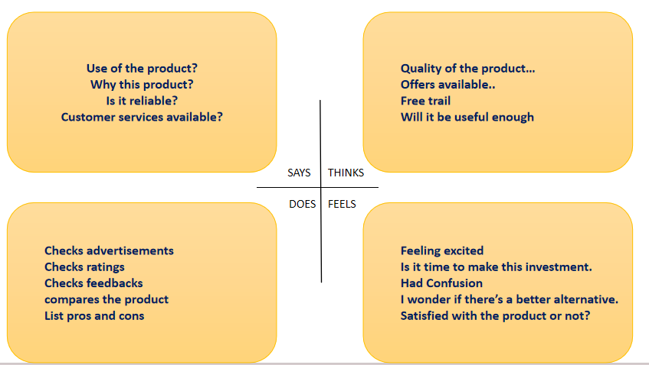

**3.2 PROPOSED SOLUTION**

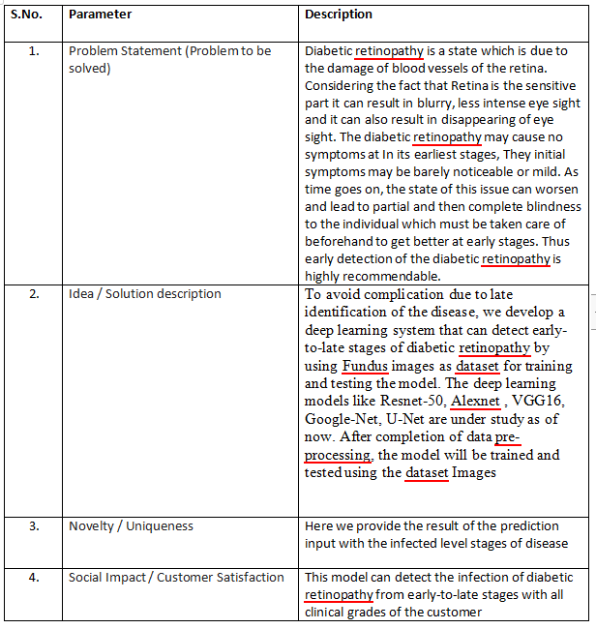

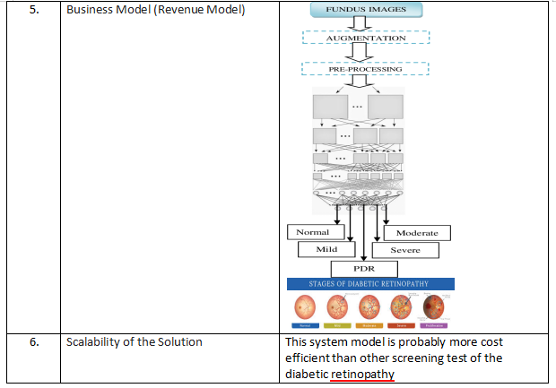

**3.3 PROBLEM SOLUTION FIT**

|  |  |  |
| --- | --- | --- |
| S.NO | PARAMETER | DESCRIPTION |
| 1. | CUSTOMER SEGMENT(S) | * People with diabetic issues * Clinics * Hospitals |
| 2. | JOBS-TO-BE- DONE/PROBLEMS | * + Should provide a fundus image of the patient as input   + The model will provide the stage level of disease of the patient too if they are diagnosed as infected, otherwise they will be declared as normal   + This model can detect the infection of diabetic retinopathy from early-to-late stages with all clinical grades of the customer |
| 3. | TRIGGERS | * High blood sugar due to diabetes * Blurriness in vision |
| 4. | EMOTIONS: BEFORE/AFTER | Emotions Before: Blurriness of vision and the fear of loss of eyesight might be experienced causing the person to lack in confidence  Emotions After: knowing the reason and the stage of infected level  of the disease helps in right treatment for the patient and help in moving on |
| 5. | AVAILABLE SOLUTIONS | * To identify the disease by retinal eye exam, diabetic eye screening |

|  |  |  |
| --- | --- | --- |
| 6. | CUSTOMER CONSTRAINTS | * Unawareness of the seriousness of the issue * The diabetic retinopathy may cause no symptoms at in its earliest stages, They initial symptoms may be barely noticeable or mild. But as time goes on it causes blurry vision and loss of eyesight. |
| 7. | BEHAVIOUR | * Visit eye doctors * Search in internet about the symptoms they face |
| 8. | CHANNELS of BEHAVIOUR | * Visiting eye doctors * Undergoing eye exams |
| 9. | PROBLEM ROOT CAUSE | Diabetic retinopathy is a state which is due to the damage of blood vessels of the retina. Considering the fact that Retina is the sensitive part it can result in blurry, less intense eye sight and it can also result in disappearing of eye sight. The diabetic retinopathy may cause no symptoms at In its earliest stages, They initial symptoms may be barely noticeable or mild. As time goes on, the state of this issue can worsen and lead to partial and then complete blindness to the individual which must be taken care of beforehand to get better at early stages. Thus early detection of the diabetic retinopathy is highly recommendable. |
| 10. | YOUR SOLUTION | To avoid complication due to late identification of the disease, we develop a deep learning system that can detect early-to-late stages of diabetic retinopathy by using Fundus images as dataset for training and testing the model. The deep learning models like Resnet-50, Alexnet , VGG16, Google-Net, U-Net are under study as of now. After completion of data pre-processing, the model will be trained and tested using the dataset Images |

**CHAPTER 4:**

**4. REQUIREMENT ANALYSIS:**

Solution Requirements (Functional & Non-functional)

**4.1Functional Requirements:**

Following are the functional requirements of the proposed solution.

|  |  |  |
| --- | --- | --- |
| **FR No.** | **Functional Requirement (Epic)** | **Sub Requirement (Story / Sub-Task)** |
| FR-1 | User Registration | Registration through Gmail |
| FR-2 | User Confirmation | Confirmation via Email |
| FR-3 | Input specification | Fundus image of retina of the patients |
| FR-4 | Product explanation | Identifies the issue at the early stage of the patient.  The deep learning model is trained and loaded, then a webpage is designed and connected to the defined deep learning model. |
| FR-5 | Prediction process | Classification of the input image using the trained deep learning model which is already connected with the web UI |
| FR-6 | Output Specification | Output with all clinical grades of the diabetic retinopathy from early-to-late stages |
| FR-7 | User requirements | Due to early stage prediction the risk of visual loss and blindness can be prevented by the proper treatment as soon as possible |

**4.2 Non-functional Requirements:**

Following are the non-functional requirements of the proposed solution.

|  |  |  |
| --- | --- | --- |
| **FR No.** | **Non-Functional Requirement** | **Description** |
| NFR-1 | **Usability** | Webpage can be accessed by the specified users assigned by the administrator |
| NFR-2 | **Security** | Authentication can be assigned only by the administrator |
| NFR-3 | **Reliability** | If errors or bugs are identified the page reload option solves the issue |
| NFR-4 | **Performance** | The output specifies the stage of disease and the model will provide specific output even for the early stage input image |
| NFR-5 | **Availability** | Quality of output and accessibility of the model is probably more efficient |
| NFR-6 | **Scalability** | This system model is probably more cost efficient than other screening test of the diabetic retinopathy |

**5. PROJECT DESIGN:**

**5.1 Data Flow Diagrams:**

Training Image

Preprocessing

Augmentation

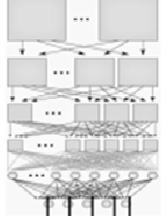

Feature Extraction

Test Image

Moderate

Normal

Severe

Mild

PDR

**5.2 USER’STORIES:**

|  |  |  |  |  |  |  |
| --- | --- | --- | --- | --- | --- | --- |
| **User Type** | **Functional**  **Requirement(Epic)** | **User Story Number** | **User Story/Task** | **Acceptance criteria** | **Priority** | **Release** |
| Diabetic Patient | Image Upload | USN-1 | The user may post a picture of eyes. | Must be able to upload easily with little verification | High | Sprint-1 |
|  | USN-2 | I will get the diagnosis report as a user within an hour. | Diagnosis must not take more time | High | Sprint-1 |
|  | USN-3 | As a user, I can receive information about my diagnosis in an easily understandable way | Information presented must be simple still having all information for the patient is necessary | Low | Sprint-2 |
|  | USN-4 | As a user, I have the option to send it to a doctor for evaluation and to receive medical advice. | Severity of disease must be notified properly | High | Sprint-3 |
|  |  |  | The information must be in a format that can be sent over mail or through other media possible | Medium | Sprint-3 |

**CHAPTER 6**

**6.1 VGG16 ARCHITECTURE**

VGG is a popular neural network architecture proposed by Karen Simonyan & Andrew Zisserman from the University of Oxford. It is also based on CNNs, and was applied to the ImageNet Challenge in 2014. The authors detail their work in their paper, Very Deep Convolutional Networks for large-scale Image Recognition. The network achieved 92.7% top-5 test accuracy on the ImageNet dataset.

Major improvements of VGG, when compared to AlexNet, include using large kernel-sized filters (sizes 11 and 5 in the first and second convolutional layers, respectively) with multiple (3×3) kernel-sized filters, one after another.

The architecture's input dimensions are fixed to (244 244), the size of the image. The mean RGB value of each pixel in an image is reduced during the pre-processing phase.

The images are sent to a stack of convolutional layers with tiny (33) receptive-field filters after the pre-processing is finished. A linear transformation of the input channels is indicated when the filter size is set to (1 1) in a few configurations (followed by non-linearity).

The convolution operation's stride is set to 1. Five max-pooling layers, which come after numerous convolutional layers, perform spatial pooling. A (2 2) pixel window is used for the max-pooling, with a stride size of 2.

Fully connected layers always have the same configuration, with the final layer having 1000 channels (1000 channels for each class), the third layer doing 1000-way ILSVRC classification, and the previous two layers having 4096 channels each.

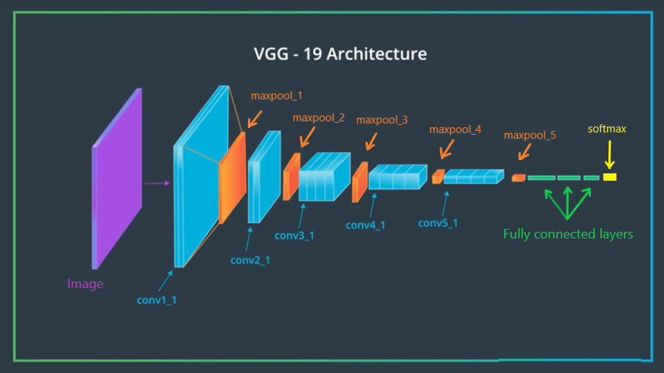

**6.2 VGG CONFIGURATION, TRAINING AND RESULTS:**

Training an image on the VGG network uses techniques similar to Training an image on the VGG network uses techniques similar to Krizhevsky et al., mentioned previously. There are only a few exceptions when multi-scale training images are involved. The dropout regularization was added for the first two fully-connected. The entire training process is carried out by optimizing the multinomial logistic regression objective using mini-batch gradient descent based on backpropagation

After training the testing is done then the model is saved in h5 format. Then the saved model is loaded for prediction which provides the result

**CHAPTER 7**

**7.1 APPLICATION**

**WEBPAGE:**

The html , css , js pages are built as per requirement where first the home page opens then registeration page is open on clicking the button or its icon then the user has to give the details and click register button then a confirmation mail is delivered to the users mail id to confirm, after confirmation the user is asked to login then after that prediction page appears then the user has to upload a fundus image of the retina to predict , then the result is displayed finally the user can logout.

**CONCLUTION:**

Thus the project provides the accurate result of the stage of the diabetic retinopathy